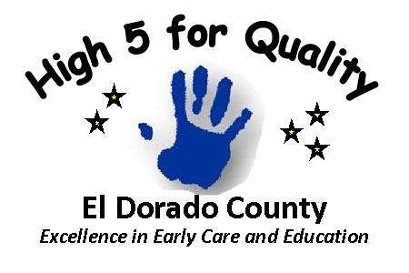

Dear XXXX(name of facility) Families,
I would like to share some exciting news! XXXX(name of facility) is participating in High 5 for Quality, El Dorado’s quality rating and improvement system (QRIS) administered by the El Dorado County Early Care and Education Planning Council. As a High 5 for Quality participant, we are demonstrating our commitment to offering high- quality child care and promoting school readiness.
You might be wondering – what is a QRIS? A QRIS is a process for supporting and rewarding child care providers for providing high-quality care. Many states and now 17 California Counties have a QRIS and El dorado is implementing our system beginning January 2013 Similar to a hotel rating, participating child care facilities are assigned a rating based on observed quality. The High 5 for Quality, quality standards look at what we know is good for children and will help them get ready for school – things like teacher and teaching, environment and program leadership, child assessment and professional development. As a participant, we will get resources to help our program including coaching, training, and scholarships.
Family engagement is an important part of High 5 for Quality. You can help support our participation by asking questions, providing feedback and staying involved. We will share our rating once it has been assigned and provide more information as needed.
If you still have questions or want more information about High 5 for Quality , please visit the Early Care and Education website. www.edcares.org
Thank you,

(Facility Director/Owner)

